**Here Comes the Sun:**

**California’s Growing Renewable Energy Production**

November 9, 2019

Scott Clark

Graham Penrose

Project Summary

In 2011, California formalized a goal of 33% renewable energy production by 2020 and has since set additional growth targets for renewables for future years. We wanted to explore California’s progress toward that goal and explore growth by renewable categories (solar, wind, etc.). We also wanted to illustrate the patterns of availability over time, given that solar and wind in particular are dependent on weather, time of day, and season. Linking availability and demand, we additionally explored how renewables typically contribute toward demand generally and during times of peak demand.

Data Sources

The California Independent System Operator (CAISO) is the non-profit that oversees the operation of the bulk of California's electric power system, transmission lines, and electricity market. Our analysis is centered on CASIO data, which represents more than 80 percent of electricity in California. There were limitations to the availability of recent data, so our project focuses on 2011 to 2017.

Datasets Used:

* Aggregated renewable energy production dataset from Kaggle:

<https://www.kaggle.com/cheedcheed/california-renewable-production-20102018>

* Annual production data from the CAISO:

<http://www.caiso.com/Pages/default.aspx>

* Demand data from the U.S. Energy Information Administration:

<https://ecdms.energy.ca.gov/elecbycounty.aspx>

Analysis

**What does renewable production growth in California look like since 2011?**

Figure 1. shows that the growth in cumulative renewable energy production per year since 2011 appears to be increasing in a relatively linear fashion. The amount of energy provided to the CAISO grid from renewable sources has essentially doubled from 2011 to 2017 (30,000-60,000 Gigawatt-hours (GWh)). If we assume this trend will stay somewhat constant until 2020, we can predict that the total renewable production for the year of 2020 will be around 75,000 GWh.

The three lines that follow a similar upward trend all include solar power, which provides most of the renewable energy for California (when compared to other sources like wind) and has had the largest growth in yearly production across the years of data available. In 2017, solar production was 25 times greater than 2011. In contrast, relatively low contributions from other renewable sources (biomass, biogas, geothermal, and small hydro) remained flat during the data timeframe and thus those sources are not considered in detail in this analysis.

*Figure 1.*

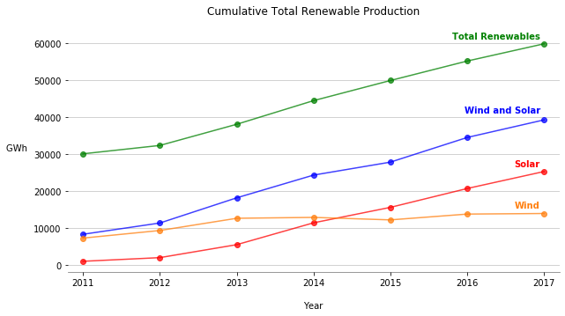

In Figure 2. and Figure 3., each dot represents an hour of continuous energy production at the corresponding Megawatt-hour (MWh) y-axis value. Every day of the year essentially has a vertical line of 24 dots (24 hours of a day), color coded for what portion of the day it falls into, set at a height equivalent to the value of the MWh production for that hour. The time that the renewable energy is provided to the grid is an important factor because there are not many effective storage methods for the power. Further, unlike a source like coal or burning natural gas for power where you can increase the plants’ production across any given hour by increasing the amount of fuel burned, renewable sources like solar power generate electricity on a time and magnitude scale determined by the environment.

Note the scales of the y-axis in Figure 2. and Figure 3., as they illustrate the growth in solar production between 2011 and 2017. The 2017 graph is nearly 20 times the scale of the 2011 graph. The increased production at midday and in the sunnier months can also be seen.

Another observation that is true for both plots is that there is generally more solar power produced in the time between the Spring Equinox and the Fall Equinox. The Spring Equinox is when the sun crosses the equator while moving north, the Summer Solstice is when the sun reaches its most positive declination (angle of sun’s position relative to a plane set through earth’s equator) of 23.5 degrees North, and the Fall Equinox is when the sun crosses the equator but moving in a Southern direction. Not only are there more relatively large MWh production values between the Spring and Fall Equinoxes, but there is also an expected increase in solar production in the hours before 9 AM and after 6PM in the 2017 plot due to the longer days.

A final interesting observation between the 2011 and 2017 solar production graphs below, is that solar production in the evening hours (later than 7PM) during 2011 seem to have relatively more markers with nearly equivalent MWh production values as markers in the daytime block across the entire year. The fact that the 2017 plot shows a more obvious distinction between solar power produced during the day and solar power produced in the morning or evening time blocks could hint at the increased efficiency of the solar panels, thus being able to capture more energy when the sun is shining with increased intensity (if we captured 100% of the energy from the sun that hit the solar panel it would be generating more electricity during the mid-day hours when the sunlight is most intense).

*Figure 2.*

*Figure 3.*

When comparing solar power’s nearly 20x growth from 2011 to 2017, Figure 4. and Figure 5. of further demonstrate that the bulk of the renewable energy growth in the CAISO grid is coming from solar power, not wind. Another interesting observation between the wind and solar scatter plots is that the majority of the higher MWh production values for solar power are in the midday period (9AM – 6PM), while wind is nearly opposite with its larger production hours falling into the morning and evening time blocks.

*Figure 4.*

*Figure 5.*

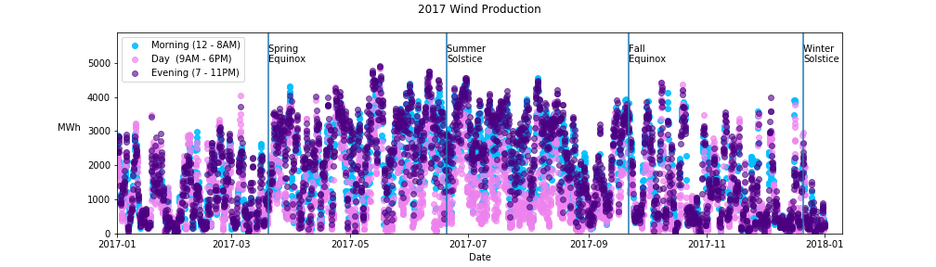

Figure 6. and Figure 7. compare total renewable energy production in 2011 and 2017. The most obvious change is the 2011 scatter follows a pattern more similar to the wind power production graphs, while 2017’s pattern is more like the solar power production pattern. This change shows how solar has become the dominant renewable power source for California in the years observed in this data set. The scale of the y-axis is important to pay attention to in this graph as well.  The max values show more than 3x growth in production across the year between 2011 and 2017.

*Figure 6.*

*Figure 7.*

Both the wind and solar scatter plots have values across the whole year that correspond to no energy production for that given hour (dots with y-value is 0). However, the plots for the total renewable energy production are consistently above 2,000 MWh.  This difference is due to the effect of other renewable sources (biogas, biomass, small hydro, and geothermal) that provide less overall energy than wind and solar.

**How does daily production fluctuate?**

The next set of visuals are box plots showing the median value, interquartile range in color, min and max values as whiskers, and outliers as dots for the amount of energy produced across every day in the 2010-2018 renewable energy Kaggle data set (2011-2017 were the only full years of data available).

Figure 8. shows solar production across the hours in a day. As expected, it shows solar power is being generated when the sun is up, and the peak production hours are in line with the peak sun intensity hours of the day (12 and 1 PM).  The large magnitude of the interquartile range shown in the solar plot is likely due to the huge increase in solar production across the span of the years in this data set.

*Figure 8.*

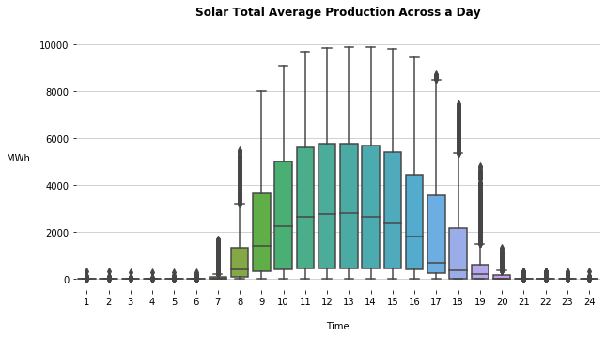

Figure 9. shows the trend in wind production across a day, and the wind’s trend is almost the opposite of the above solar production graph.  The median values for the peak production hours are significantly smaller for wind production than solar, but this is to be expected with the knowledge of solar power’s explosive in growth from 2011 to 2017.  Further, relative to the scale of the chart, the wind box plots have a somewhat large interquartile ranges and therefore have a relatively large standard deviations within the data for each hour of the day. With the knowledge of the relative lack of growth for wind in the first yearly production line chart, this standard deviation may point at the fact that wind is a less reliable source in terms of how much power it produces at a given hour.

*Figure 9.*

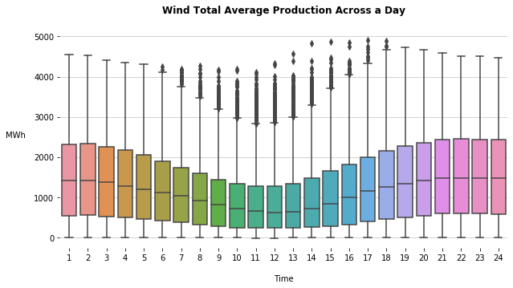

Figure 10. shows the trend in total energy produced from all renewable sources across a day. The general increase in production across the daytime hours of the day reflects the significant contribution solar power makes to California’s renewable energy production. Of note, the interquartile ranges in this graph are significantly larger in the hours that solar is providing power, similar to the solar production per hour chart. This is because solar has had so much growth over the time period captured in our data set. Noting that when solar power is not online (when the sun is down), all the hours have relatively smaller interquartile ranges shines a light on another interesting observation. The relative lack of variance in hours when the renewable energy is coming from wind and all other smaller sources (biogas, biomass, etc.), seems to show that these sources have had less growth in energy produced from 2010 to 2018.  A topic that could be researched further would be the causal factors for the lack of growth in energy production from other renewable sources.

*Figure 10.*

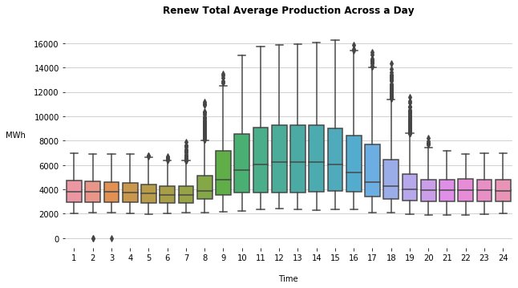

**How does monthly and hourly production in 2017 compare to 2011?**

When looking at energy production across the hours of a day, again the midday contribution from solar energy stands out in Figure 11. The main difference between 2011 and 2017 is the additional production that occurs during daylight hours in 2017.

*Figure 11.*

In terms of monthly production in 2011 compared to 2017, Figure 12. shows that the most power produced by renewables in 2011 was just less than 3,000,000 MWh in May and August. By 2017, renewables were producing about twice that amount for those months. The contributions of solar stand out again, as the most gains were made in typically sunnier months of the year.

*Figure 12.*

The growth in solar production from 2011 to 2017 is made even more clear in the following chart. The impact of seasonal changes also appears to limit the relative increase in solar production for the months with less daylight.

*Figure 13.*

**What percent of annual total energy demand is provided by renewables?**

By 2017, California was closer to meeting its goal of 33% renewable energy. On average in 2017, renewables provided 26% of energy. Since solar is the largest provider, it is not surprising that the smallest proportion of renewable energy was provided during the winter, when there are the fewest hours of daylight. Sunny, but not too warm spring, was the period when renewables contributed the highest proportion of energy, with 32% in April and May.

*Figure 14.*

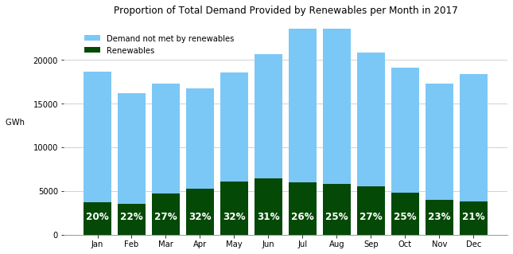

**What is the snapshot of renewable energy contributions on a peak load day?**

We used CAISO data to identify the day with the highest energy demand for our study period, which was September 1, 2017. As expected, renewables contributed the most energy during the daylight hours and contributed the highest proportion of energy (35%) at 9 a.m.. At the hour of peak demand (5 p.m.) renewables contributed only 16%. With the sun still shining, it appears there was additional opportunity for solar contribution at the peak load hour.

*Figure 15.*

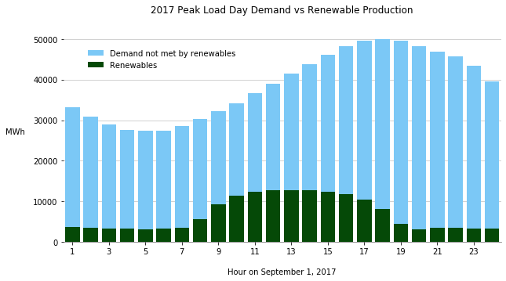

**Final Note: Combined Smaller Renewable Resources:**

Figure 16. is a box plot of combined hourly production of the renewable sources not focused on in this analysis. The cumulative power production values from these resources are included in any chart showing “Total Renewables”, but these sources remain relatively constant, so they aren’t focused on. The combined sources charted below are compiled from the hourly sum of production from biogas, biomass, small hydro, and geothermal across all years in the Kaggle data set.

*Figure 16.*

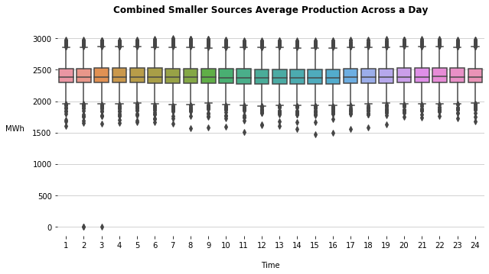

Figure 17. is a scatter chart similar to the solar power, wind, and total renewable scatter plots, showing the combined production of the same smaller renewable sources as above. Simply to show they stay relatively constant across the year and don’t have much hourly/ seasonal fluctuation.

*Figure 17.*

